CTA-1 - Data Structures Demonstration Screenshots

Image 1 – Main Menu
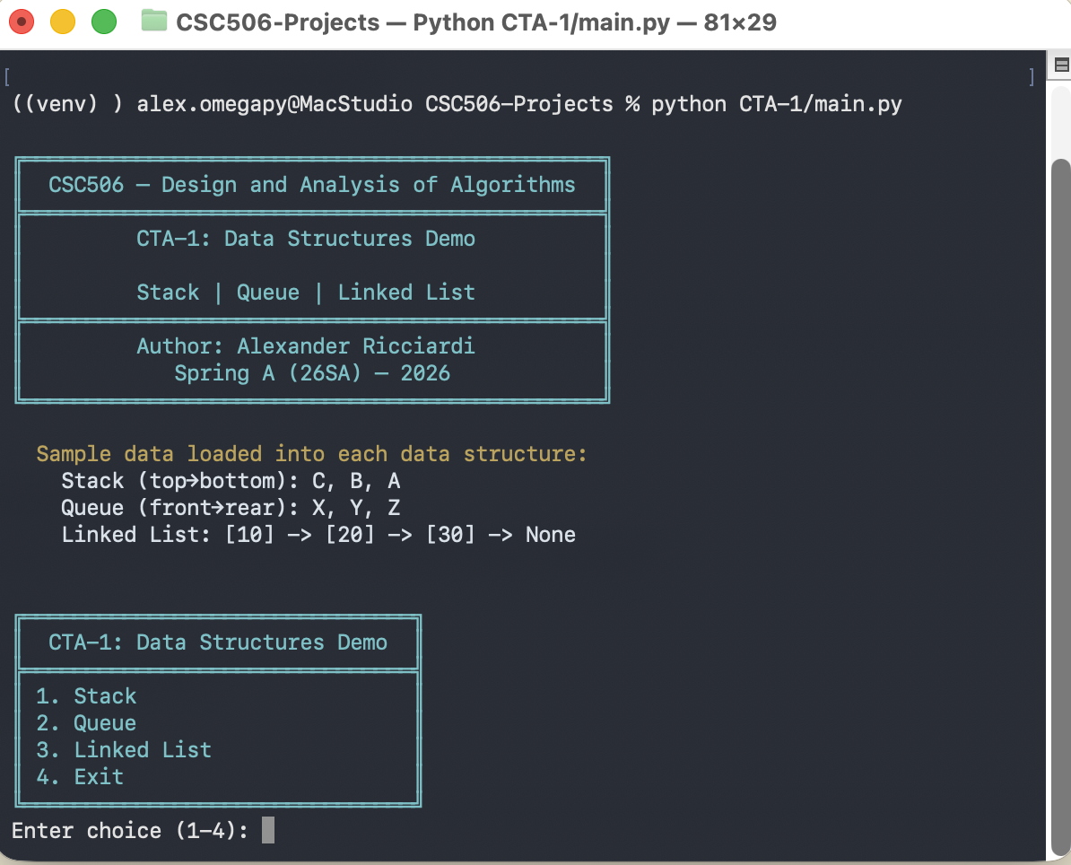

See next page

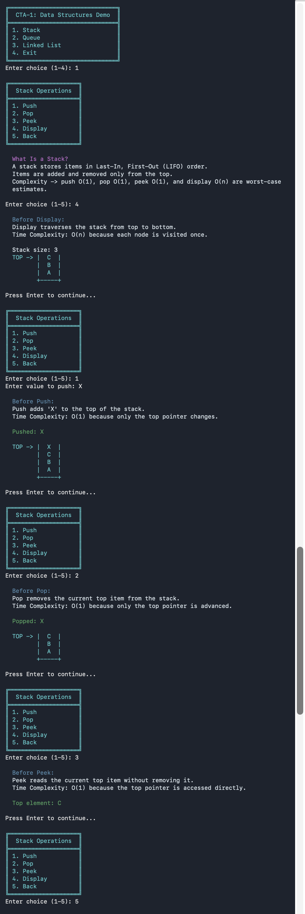
Image 2 – Stack Operations

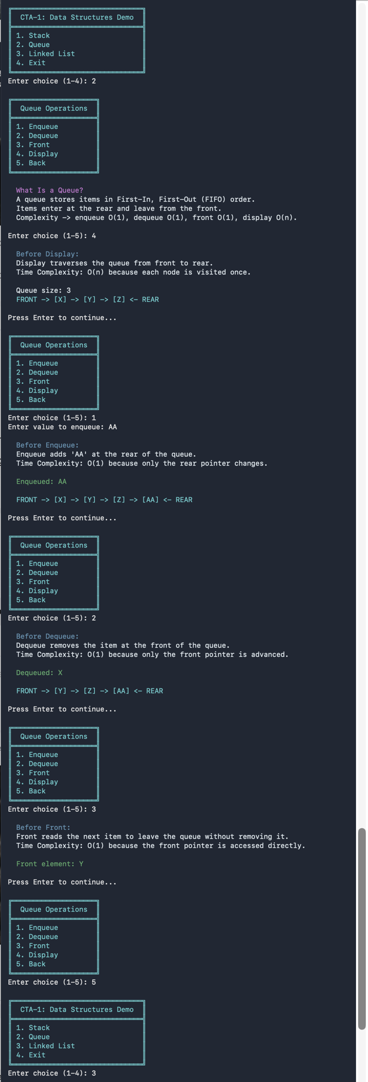
Image 3 – Queue Operations

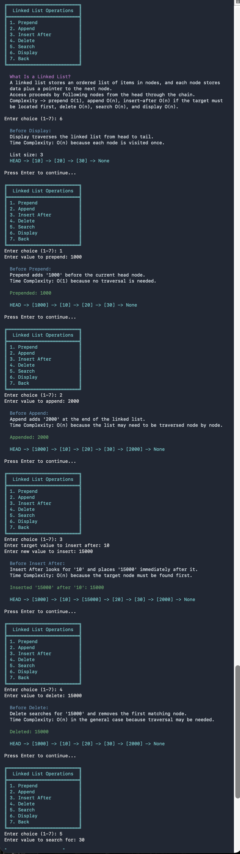
Image 4 – LinkedList Operations

